Body Modifications: A Living Art

Hannah Garrett
Cazenovia College
Marketing Research
Megan Lawson-Clark
December 5th, 2022

Abstract:
Body modifications have a vast and rich history, both religiously and culturally, and hold a deeper meaning than what is taken at face value. To better understand the who, what, where, when, why, and how, body modifications must be examined through a psychological and anthropological lens. The practice of body modifications must be viewed as an artform. This paper will explores the different types, history of body modifications, and significances behind the practice of body modifications.

The world of body modifications has always seemed elusive, an underground practice or specific to specific cultures, however, it is becoming more commonplace. Humans have a long history with the practice of body modifications, despite it not always being widely accepted. From the use of tattooing for religious and cultural reasons, to show group affiliation, and to express individuality, body modifications have been used to record significant life experiences. Today, many regard body modifications as an artform.. Looking at body modifications through an anthropological and psychological lens can enhance one’s understanding of these practices.
The definition of a body modification is as follows: Body modification is the deliberate altering of the human anatomy or human physical appearance. In it broad, it includes skin tattooing, piercing, branding, scarification, tongue splitting, cosmetic surgery procedures, and gender reaffirming procedures. Non-consensual modifications such as circumcision (male and female), disfigurement, and mutilation are also included in this definition. The focus of this paper will solely be on consensual modifications such as piercing, tattooing, and “socially acceptable” body modifications.
While there are many different types of body modifications, the most “socially acceptable” forms of body modifications include single or double lobe piercings, single nose studs, and minor cosmetic alterations such as dyed hair, false nails and eyelashes, dieting, working out, and shapewear. Many individuals may not consider cosmetic alterations as body modifications because they are more minor and socially acceptable than other forms of body modifications. By definition, however, they fall under the category of body modifications.
There are many different types of piercings available, and most parts of the body have the ability to be pierced, common spots the ears, nose, and lips, to more uncommon and intimate locations such as the genitals. There are more specific names for each location of piercing, such as a Monroe (See Figure 1 in Appendix) piercing, which is a lip piercing that is located on the upper lip similar to the placement of Marilyn Monroe’s iconic mole.
Tattoos are much more diverse than piercings, from the style of the tattoo to the placement. There are even different types of ink an artist can use, including a semi-permanent ink called Ephemeral Ink, designed to fade and completely disappear after 9-15 months (Ephemeral Ink). Some of the most popular styles include American Traditional Tattoos (See Figure 2 in Appendix), originally known as Sailor Jerry Tattoos, fine line tattoos which are aptly named after the delicate lines of the tattoo style, realism, blackwork, and Japanese Style. While every artist and client are different, many work together to develop a personal tattoo.
Extreme body modifications are less common, and may include scarification, branding, tongue splitting, and surgeries to drastically change one’s appearance. While many people do not practice extreme body modifications, most notably of those individuals include Lucky Diamond Rich (See Figure 3 in Appendix), a man whose body is 100 percent covered in tattoos, Rolf Buchholz (See Figure 4 in Appendix) who has 481 piercings, as well as multiple implants, and Catman Dennis Avner (See Figure 5 in Appendix) whose body modifications helped him take on the appearance of a cat. Although these individuals happen to be the exception, there is a large number of those who choose to partake in the practice of extreme body modifications. Many of these individuals are those from countries and whose culture promote and embrace such practices.
Body modifications have a vast history ranging from the ancient Egyptians, to the European Bronze Age, to modern day. In 1991, in the Alto Adige Region (northern Italy bordering Switzerland and Austria), Öizi the ‘Ice Man’ (See Figure 6 in Appendix) was discovered, his mummified remains donned in small tattoos, dating back to 3300 BC. Ötizi is not the only historical evidence of body modifications. Many depictions of humans in ancient and classical art show decorated bodies. These decorations are thought to have been tattoos, scarification, or branding, rather than decorative body paint, clothing, and jewelry (Jones).
In 1716, “…two ‘American Princes’, allegedly captured ‘on the coasts of Brazil’” (Oettermann, 194). It is said that these two ‘American Princes’ (See Figure 7 in Appendix) were Native American men whose bodies were highly decorated in tattoos. They were captured and brought around the world as a spectacle, only to then be inducted into the protestant faith and baptized under new German names. This liberated from their ‘spiritual and physical slavery’ and were then sent on as a “gift” to the Tsar of Russia in Petersburg (Oettermann).
The history of body modifications is more brief with Euro-American history than with the rest of the world. Many individuals with body modifications were those who had cultures, religions, and beliefs in which these practices were sacred. Kim Hewitt, author of Mutilating the Body: Identity in Blood and Ink writes: “Although the origin of tattooing is uncertain, anthropological research confirms that tattooing, as well as other body alterations and mutilations, is significant in the spiritual beliefs of many cultures” (Hewitt, 65-73). Body modifications such as tattooing has long been used for spiritual and healing purposes, as well as aesthetics for as long as the practice has existed. With the Thracians, and Indo-European people who mainly resided in the Balkans in 1300 BC, it is not presumptuous to assume that tattooing was likely to be connected with the status of the family or clan. (Jones, 5). While historians may not know the exact significance surrounding this ancient people’s tattoos, this does help to continue dating the evidence of tattoos around the world.
Regarding the significance behind body modifications, Kim Hewitt writes: “Without an understanding of manipulation of the body to inspire ‘sacred awe’ in viewers and bearers of tattoos and other body alterations, one can not grasp the significance of these alterations as tangible establishments of personal, spiritual, and social identity” (Hewitt, 73). Examples of body modifications from around the world include nose piercing (See Figure 8 in Appendix) associated in India which signifies womanhood and elegance in a coming-of-age ritual. Neck elongation (See Figure 9 in Appendix) in Thailand and Africa signifies beauty. Henna tattooing in Southeast Asia and the Middle East signifies good health and a prosperous marriage. Tooth filing in Tanzania as a coming-of-age ritual for both boys and girls, spiritual protection, and as a general cultural custom. Lip plates and earlobe stretching in Africa is a symbol of beauty and pride. The size of the plate correlates to the amount of their dowery. Other body modifications affiliated with culture include foot binding in China, from the 10th century through the mid 1900s, as well as corsetry in Europe in the 16th-19th century. In addition traditions and meanings behind body modifications include the traditional South Pacific Tonga society in which only priests could tattoo others and tattoos were symbolic of full tribal status. Traditionally, Eskimo women tattooed their faces as well as their breasts, and believed that acquiring sufficient tattoos guaranteed a happy afterlife. In many African cultures scars (tribal scars) indicate social status and desirability as a marriage partners. The Cree Indians living in the Great Plains consistently tattooed for luck, for beauty, and to protect their health (Hewitt). As with anything that humans do, body modifications are one of the many practices that humankind participates in that has a deep and rich background.
Religion also influences the practice of body modifications, “cultural practices of body mutilation are often functionally akin to prayer as a practice that spiritually elevates an individual” (Hewitt, 65). What ones does to their body can be traced back to their religion. Kim Hewitt discusses how in the early 19th century; religious pilgrims would be tattooed by the Romani peoples after visiting the Holy Land. “At the turn of the nineteenth century, it was traditional for Gypsies to tattoo these pilgrims, and the tattoo marks became part of the pilgrim’s social status. …Because only religious pilgrims were tattooed, the religious tattoos were also known as Mahdesi [translates as “I saw death” in Armenian]. The tattoo is a code indicating a spiritual passage, or at least a religious pilgrimage” (Hewitt, 66). These tattoos, seen as a religious “rite of passage” also symbolized the entry into a “higher plane of spiritual existence and exemplify the overlap between Christian beliefs and body magic” (Hewitt, 67). The pilgrims saw the tattoos as a promise into heaven, to show that they have done their duty as a missionary, spreading the word of God.
While body modifications can have religious significance, in some religions, such as Christianity, body modifications can be seen as sacrilegious. Some people see the body as sacred, and marking one’s body is seen as vane and a sign of impurity. Other religions, such as Judaism and Islam also hold similar beliefs. However, many individuals who practice religion are not as strict with these beliefs. “Body alteration seems to serve a need deeper than that addressed by modern Christianity or other institutionalized religious or cultural avenues in the Euro-Western world. Perhaps the oldest art known to human beings, and the most ancient method of expressing personal and communal spiritual beliefs, body alteration has persisted until the present day in various magico-religious and secular forms” (Hewitt, 67).
As seen on social media and popular culture, especially in the era of Tumblr and early Instagram, the Buddha and Mandala was a popular religious icon to tattoo on one’s body in the early 2010s. A simple cross is popular among those belonging to the Christian or Catholic faith. Many of those who are part of a religion, who choose to have body modifications such as tattoos, tend to lean toward scripture that resonates with oneself. The “Tree of Life”, a complete circle with a tree in the center, whose branches and roots meet, originally belonged to Norse religions, is now another popular symbol for those who belong to Christianity or Judaism to have tattooed on oneself.
Another significance that body modification may possess is group affiliation. Lee Barron in his book Tattoo Culture: Theory and Contemporary Contexts discusses the view of an early 19th century Italian criminologist Cesare Lombroso. Lombroso tries to make the connection between criminals and their “bodily traits” such as large jaw bones or receding foreheads. Lombroso also cited tattooing as a further indicator of a criminal tendencies, stating that tattooing occurs only among the lower classes, in which he includes peasants, sailors, workers, shepherds, soldiers with an emphasis on criminals (Barron). While the theory that a criminal can be distinguished from a law-abiding citizen because of a bodily feature has been long disproven (and is deeply rooted in racism), there can be connections made between gang related crime/violence and those who have tattoos which connect oneself to said group/gang (Barron).
There is a long-standing taboo against tattoos in Japan, and the young Japanese are fighting back against it. Tattoos are still seen as a sign of gang affiliation and organized crime in Japan, even though the Japanese Mob has all but faded into history, and tattoos are becoming more culturally accepted in other countries. “Tattoos have a long history in Japan, and they were important to women in Indigenous Okinawan and Ainu communities.” (Hida) However, their association with crime goes back about 400 years. For instance, they were used to brand criminals with marks that varied by region and crime, such as a circle, an X, or the Chinese character for dog. Tattooing was banned in 1868 as the practice was seen as “barbaric” when the country started promoting Western-style modernization policies. “Although that ban was lifted in 1948, the stigma remained. Yakuza, or Japanese gangsters, often have neck-to-ankle “wabori,” a traditional Japanese-style tattoo done by hand using needles.” (Hida). Because of this stigma the Japanese have with tattoos, many institutions still ban those who have visible tattoos.
“In Lombroso’s view…the tattoos worn by his criminal sample acted as signs, and more specifically, indicators of class” (Barron, 11). Lombroso’s views have been discredited time and time again, and the outdated views are fading farther into the past. However, it cannot be completely discredited that there are instances in which groups/gangs use tattooing as a way to “brand” their members as one of their own. The most notable of these tattoos include a teardrop placed under the eye which is said to symbolize that the person has killed someone. This meaning is not the rule, however, and can also represent that the person has experienced loss or has done time in prison (Mahoney).
Despite the reasons listed above, the main reason for body modifications today is to develop one’s individuality in a deeper and more personal way. When Personality gets Under the Skin: Need for Uniqueness and Body Modifications written by Selina M. Weiler, Bjarn-Ove Tetzladd, Phillipp York Herzberg, and Thomas Jacobsen for Plos One (a peer-reviewed open access scientific journal published by the Public Library of Science) in 2020 delves into the “Need for Uniqueness” (NfU). “A consumer’s need for uniqueness is defined as an individual's pursuit of differentness relative to others that is achieved through the acquisition, utilization, and disposition of consumer goods for the purpose of developing and enhancing one's personal and social identity” (Tian).
The researchers conducted an anonymous study of 312 participants who have body modifications ranging from none to extreme. The researchers wanted to determine the motives for modifying one’s body. They used the German NfU-G global scale and three sub-scales to make these observations. The three subscales include “Factor 1: reflects a lack of concern regarding others’ reactions to one’s different ideas, actions and so on” (Weiler). “Factor 2: reflects a person’s desire to not always follow rules” (Weiler). “Factor 3: reflects a person’s willingness to publicly defend his or her beliefs” (Weiler). The study found that tattooed, pierced, and extreme body modified individuals have a higher NfU-G score than those without. It also found that tattooed individuals took a social component into consideration, while lacking the concern regarding others’ reaction towards the tattoos. Pierced and extreme body modified individuals “tended to display a propensity to actively flout rules and not worry about others’ opinions” (Weiler). This study also found that the number of body modifications increased with an increasing NfU. “…the motivations for tattooing are frequently driven by the desire to mark the body with an expression of the individualized self, while being part of a bodily process that has arguably attained its highest degree of social and cultural visibility and apparent social acceptance” (Barron, 24-25). While tattoos are rising in popularity, as Barron writes, tattooing, and body modifications as a whole have a deeper meaning, whether it be cultural, religious, or for self-expression. Tattooing can also represent solidarity, whether it be a matching tattoo with a partner, a memorial tattoo, or related towards a movement. Lee Barron writes about Amy Blueuel’s Project Semicolon, a web-based, evocative, contemporary expression of the cultural significance of tattooing. Established in 2013 in tribute to her father who committed suicide and serves as a movement offering hope. The mission was for other individuals experiencing the effects of suicide to get tattoos of semicolons, to represent that their story is not yet over (Barron). The reason behind obtaining body modifications don’t have to have deeper meaning like Project Semicolon; “…some clients sought tattoos in imitation of a tattooed figure from popular culture or sought to copy a design seen in everyday life, while other were tattooed in the pursuit of narcissistic enhancement, arguing that tattoos would render an already beautiful body even more aesthetically pleasing” (Barron, 4).
Despite the endless influences behind the decision to have body modifications, there are still many stigmas surrounding such practices. Stigma: deriving from the Latin word stigmata meaning “mark” or “brand” and the Greek word stizein meaning “to tattoo”, now, according to Random House Webster’s College Dictionary, has the definition of “1. A stain reproach, as on one’s reputation. 2. a. a mark or obvious trait that is characteristic of a defect or disease…” (1285). Many of the stigmas surrounding body modifications come from a lack of understanding of the origin of the body modifications history and practice. The most “popular” of the stigmas associated with body modifications such as tattoos and piercings, include being a criminal, a drug addict, being more rebellious and less intelligent, and having lower levels of inhibition. Another stigma is that people who get body modifications are thrill-seekers and impulsive and engage is risk-taking behaviors (Mehta). There is virtually zero proof that body modified individuals are more likely to support these stigmas.
In Japan, where tattoos are still looked down upon due to past gang ties, many of those with tattoos face limitations. “Because of this gangster association, many hot springs resorts, beaches, and gyms bar people with tattoos. Office jobs that allow tattoos are still sparse to nonexistent, with many companies expressly prohibiting applicants who have them. Tattoos are also frowned upon as a violation of communal codes for how Japanese people should look — codes that can carry severe penalties for anyone who deviates from them” (Hida). Discrimination in the workplace against those with “alternative” style body modifications (tattoos, facial piercings, unnaturally colored hair, etc.) is still prevalent.
To understand the stigmas, the history of body modifications must be considered, as well as the psychology and internal biases surrounding body modifications. “The lack of understanding of the functional purposes of both the tattooing process and the final marks have led to a perception of tattooing as barbaric, deviant, and sexually perverse. Dominant American culture has considered tattoos as marks of degradation, criminality, and marginality” (Hewitt, 73). As Victoria Pitts discussed in the book In the Flesh: The Cultural Politics of Body Modifications, the body art movement in the United States increased exponentially in the 1990’s and have been politicized and “socially problematized” (Pitts, 23). She goes on to discuss how “new” body modifications are seen as “challenging the Western Body norms” in “postmodern culture” (Pitts, 23). Modified gay and female bodies are especially likely to be discriminated against due to the already discriminatory nature of these marginalized groups. Victoria Pitts then posits “from post-essentialist perspectives, the historic and geographic diversity of bodies and body practices point not only to the body’s shaping by and through cultural practices, but also to the impossibility of a natural model of the body” (Pitts, 29). Body politics have long been debated, and with the rise in body modifications, the conversation is more prevalent than ever.
Stigmas of any form about any group is incredibly harmful and having stigmas against body modified individuals has very little to do with the individual as a whole, and more about the perceived notion regarding said body modifications. Psychologically speaking, those who get body modifications are reported to feel more attractive, stronger, and more self-confident (Roggenkamp). Body modifications also hold personal value, whether it be culturally significant, or have personal significance. Individuals who have body modifications are harshly judged in the workplace, in professional and formal settings, and are disregarded because of their individual choices they choose to make regarding their body. Not every body modified person is treated equally. Celebrities with body modifications are thought to be cool and trendy, while “regular” people are judged for the same modifications (Mehta).
As body modifications are becoming more widely accepted, the practice and result is slowly being seen as an artist and their art. Susan Benson argues “…the commodification of these practices and their claims to be ‘art’ require us to treat them as no different from any other form of personal consumption in the West” (Benson, 244). A naked individual with tattoos is no less dressed than a non-tattooed individual who is completely clothed. A man with a thousands of dollars of body modifications is no different than a man in a designer suit and luxury watch (Benson).
A non-traditional form of art, body modifications are bursting into the more traditional art scene. As tattooists and piercers define themselves simply as ‘artists’ and the present their work as ‘art’, the larger and formally traditional art world has begun to take notice of the non-traditional medium. Tattooing is increasingly legitimized as art and increasingly the works are shown in museums and galleries and are subjected to critics by the traditional art world (Sanders). Sanders continues to discuss how the current day body modification movement is a new type of renaissance. A key element of the development in body modification culture throughout the twenty-first century has been the artistic quality that has emerged. “As Lola Mars states, ‘Tattoos are art; and an art form at the peak of groundbreaking innovation at that” (Barron, 24). With body modifications becoming ever present in mainstream culture, trends can be seen forming throughout the world. The trends change throughout the years, much like trends in every area of our lives. As seen on major social media platforms such as Instagram, TikTok and Pinterest, the main tattoo trends that have popped up for 2022/23 include: red ink tattoos, fine line tattoos, “faux” freckle tattoos, 90s revival, vivid colors within tattoos, abstract art tattoos, and symmetrical tattoos. Piercing trends include: “constellation” ear piercings, jewelry charms, ear stacks, septum rings, and nostril cuffs. The rise in social media is a major contributor to the ever-changing trends in the majority of the facets of our lives, including body modifications, and that in itself is changing the history of how body modifications move throughout our existence as human beings. With the aid of social media, many ‘artists’ have been able to grow their platform and reach new audience members that would not have been available otherwise. This also helps allow these ‘artists’ break into other areas of the art world such as NFT art as proven by local Syracuse, New York tattooist Sean Morgan (@seanisweird on Instagram) who recently had collaborated with Urban Outfitters (See Figure 10 in Appendix). Modern day body modification culture is growing and “…within our contemporary culture, it seems that tattoos are everywhere” (Barron, Introduction). From your local coffee shop barista, famous athletes, and even A-List celebrities such as Johnny Depp and Rihanna, heavily tattooed bodies within the mainstream are now commonly showcased (Barron).
Just like with body modifications, clothing is a testament to our true selves. In Dressed: A Philosophy of Clothes written by Shahidha Bari she states that “…life happens in clothes…We are dressed. In all parts of culture- literature, music, film, and art- we find the representation of clothes…Our deepest internal life is found in them” (Bari, 4-5). My senior collection consists of five ensembles including three women’s wear pieces and two men’s wear pieces. This collection is titled “Body Modifications: A Living Art”. This is a ready-to-wear, fall/winter, streetwear collection with elements of couture for a more elevated take on the streetwear aesthetic. The garments have components of asymmetry as the majority of tattoos are not symmetrical. The use of interesting style lines helps reinforce this narrative. The majority of the garments are black and white, as the main style of tattoo that I am referencing for my collection is Black and Grey American Traditional Tattoos, as well as the use of chains, grommets, and small gems to interpret the reference of piercings. Textures also play a big role in this collection as tattoos are a visual texture. With the majority of the collection being black and white, leather, denim and sheer fabrics will make up the main fabric choices. This helps tie in the ruggedness of body modification culture, as well as the streetwear influence. I have also be added in personalized, hand drawn “tattoos” on selective parts of the garments to tie in the artists aspect of tattoos.
Trends that I referenced for this collection include corsets, interesting necklines, sheer fabrics, contrasting textures, defined waistlines, chains, gold accents, and mixed metals.
A longstanding tradition in multiple cultures body modifications are an artform and should be considered as such. Kim Hewitt credits tattoo artists noting that the rise in new technology and an interest in tattooing as a fine art have produced new and higher standards. Body modifications and tattooing in specific has become more professional and more of a fine art (Hewitt). The many types of body modification available to individuals allow for full creativity between artist and consumer. The culture behind and correlation between body modifications, art, and clothing are present now more than ever. As tattoos, piercings, and colored hair have become a central component of celebrities and how a body is represented, the extent to which tattooing is now a significant aspect of self-presentation. Bodily transformation and modification is a universal aspect of fashion, and tattooing has now become a more present sign within the modern and high fashion industry (Barron). More so now than ever in the fashion industry and art world in general, body modifications are becoming a hot topic. Some of the top models who are employed by the top designers are covered in tattoos, such as Cara Delevingne and Stephan James. Lee Barron continues by saying there is an increasing interest for the modified model body, in which tattooing has become incorporated into the high fashion industry, proving both a “badge of identity and a personal signature: an exotic statement within a fashion system (Craik, 1994, p. 25)” Barron, 39). Body modifications, specifically tattooing and piercing is an artform with a live canvas, arguably one of the most sacred practices of art, with a deeply cultural and religious past. While it has not always been so highly regarded, the practice of body modifications is growing in popularity throughout the world. In time, body modification may be put on the same pedestal as other traditional forms of art.

Works Cited:
“Adornment: Tattooing and Piercing.” Mutilating the Body: Identity in Blood and Ink, by Kim Hewitt, Bowling Green State University Popular Press, 1997, pp. 65–73.
Bari, Shahidha. Dressed: A Philosophy of Clothes. Basic Books, 2020.
Barron, Lee. Tattoo Culture: Theory and Contemporary Contexts. Rowman Et Littlefield International, 2017.
Benson, Susan. “Inscriptions of the Self: Reflections on Tattooing and Piercing in Contemporary Euro-America.” Written on the Body: The Tattoo in European and American History, edited by Jane Caplan, Reaktion, 2000, pp. 234–254.
Ephemeral Tattoo ®, ephemeral.tattoo/.
Hida, Hikari. “Discreetly, the Young in Japan Chip Away at a Taboo on Tattoos.” The New York Times, The New York Times, 23 Apr. 2022
“Introduction.” Customizing the Body: The Art and Culture of Tattooing, by Clinton Sanders, Temple University Press, 1989, p. 19.
Jones, C. P. “Stigma and Tattoo.” Written on the Body, edited by Jane Caplan, Princeton University Press, 2000, pp. 1–16.
Koslofsky, Craig. “Slavery and Skin: The Native Americans Ocktscha Rinscha and Tuski Stannaki in the Holy Roman Empire, 1722–1734.” Beyond Exceptionalism: Traces of Slavery and the Slave Trade in Early, edited by Rebekka Von Mallinckrodt et al., DE GRUYTER OLDENBOURG, 2021, pp. 93–123.
Mahoney, Mark, et al. “Teardrop Tattoo (Various Designers).” Design and Violence, 10 Mar. 2015, www.moma.org/interactives/exhibitions/2013/designandviolence/teardrop-tattoo-various-designers/.
Mehta, Vinita. “Are People with Tattoos Stigmatized?” Psychology Today, Sussex Publishers, 28 Sept. 2018, www.psychologytoday.com/us/blog/head-games/201809/are-people-tattoos-stigmatized.
Oettermann, Stephan. “Tattooed Entertainers in America and Germany.” Written on the Body: The Tattoo in European and American History, edited by Jane Caplan, Reaktion Books, 2000, pp. 193–211.
Pitts, V. In the Flesh: The Cultural Politics of Body Modification. Palgrave Macmillan, 2015.
Roggenkamp, Hannah et al. “Tattoos as a window to the psyche: How talking about skin art can inform psychiatric practice.” World journal of psychiatry vol. 7,3 148-158. 22 Sep. 2017, doi:10.5498/wjp.v7.i3.148
“Stigma.” Random House Webster's College Dictionary, Random House, 1999, p. 1285.
Tian, Kelly Tepper, et al. “Consumers' Need for Uniqueness: Scale Development and Validation.” Journal of Consumer Research, vol. 28, no. 1, 1 June 2001, pp. 50–66., doi:10.1086/321947.
Weiler, Selina M., et al. “When Personality Gets under the Skin: Need for Uniqueness and Body Modifications.” PLOS ONE, vol. 16, no. 3, 2021, doi:10.1371/journal.pone.0245158.

Photographs Cited:
Atwal, Sanj. “Extreme Body Modifications: Record Breakers and Why They Do It.” Guinness World Records, Guinness World Records, 26 Nov. 2021, www.guinnessworldrecords.com/news/2021/11/extreme-body-modifications-record-breakers-and-why-they-do-it-683652.
“Becoming Something Else.” CNN, Cable News Network, 7 Nov. 2013, www.cnn.com/2013/11/07/health/gallery/body-modifications/index.html.
Campagnola, Serena. “Kayan Woman in Chiang Mai, Thailand.” Atlas of Humanity, www.atlasofhumanity.com/thailandkayan.
“Get to Know the Cryptoon Goonz.” Urban Outfitters, www.urbanoutfitters.com/uo-community-cryptoon-goonz.
Ishak, Natasha. “This 60-Year-Old Man Just Claimed the World Record for Most Body Modifications.” All That's Interesting, 2 Nov. 2020, allthatsinteresting.com/rolf-buchholz.
“Matt Houston (@matthew_houston).” Instagram, www.instagram.com/matthew_houston/.
O'Neal, Meghan. “Monroe or Madonna? Why We Love These Upper Lip Piercings.” FreshTrends Body Jewelry Blog, blog.freshtrends.com/monroe-madonna-upper-lip-piercing/.
Samadelli, Marco, et al. “Fig 2.” Research Gate, Journal of Cultural Heritage , Jan. 2015, www.researchgate.net/figure/The-set-of-tattoos-seen-through-the-results-of-the-processing-obtained-by-combining-the_fig2_271225488.
Woman Wearing Court Dress and Indian Jewelry. Washington, D.C., 1890.

Appendix:

Figure 1: Monroe Piercing (O’Neal, Meghan).
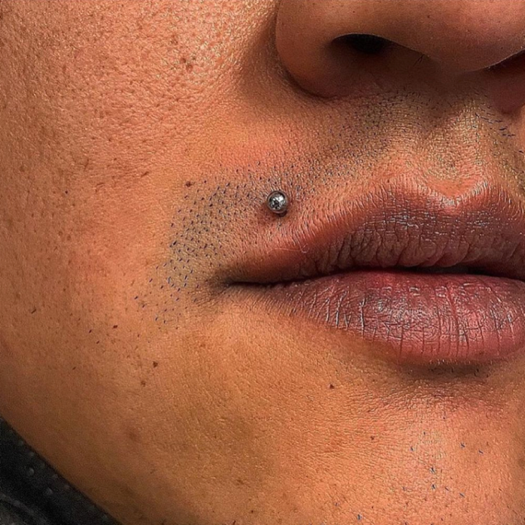

Figure 2: American Tradition Tattoos (Matt Houston).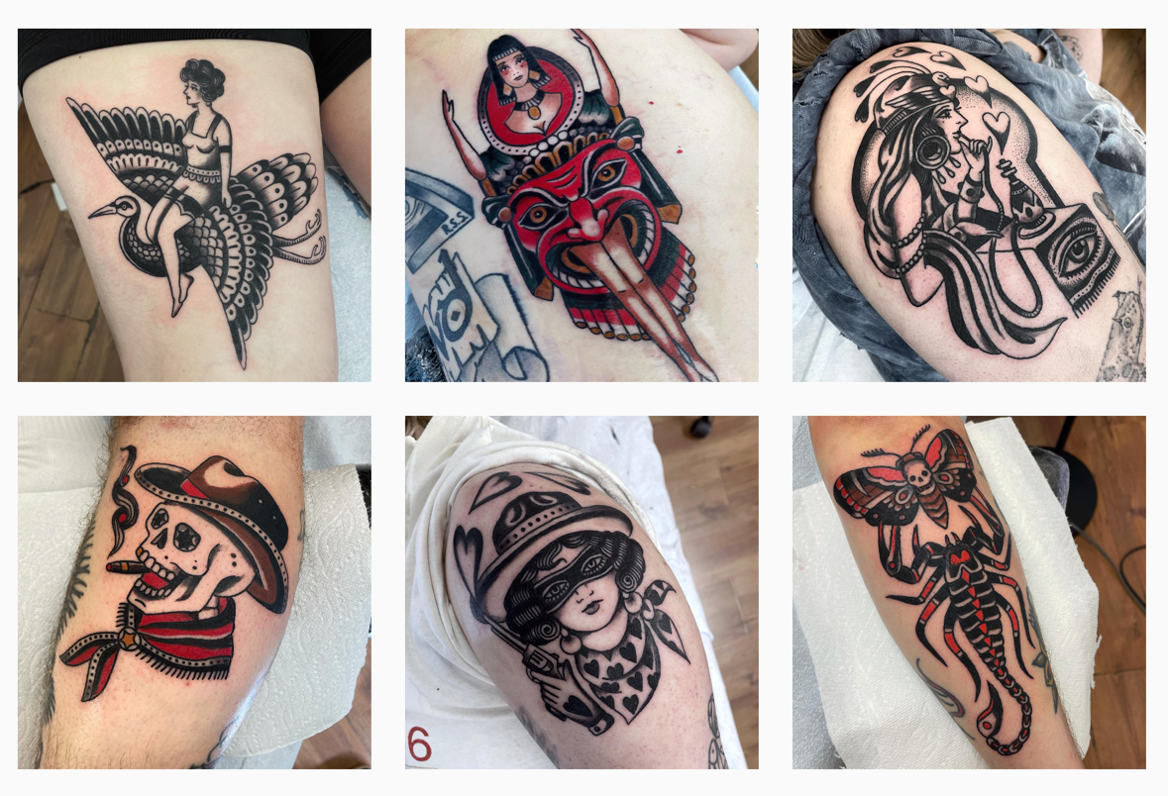
Figure 3: Lucky Diamond Rich (Atwal, Sanj).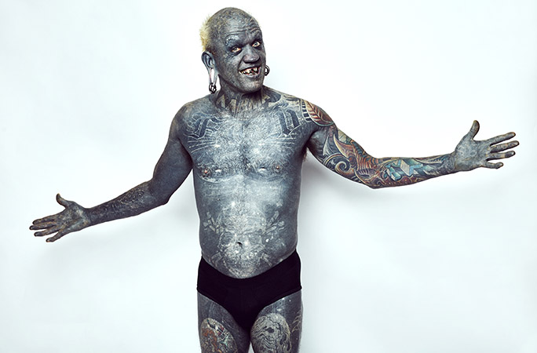

Figure 4: Rolf Buchholz (Ishak, Natasha).
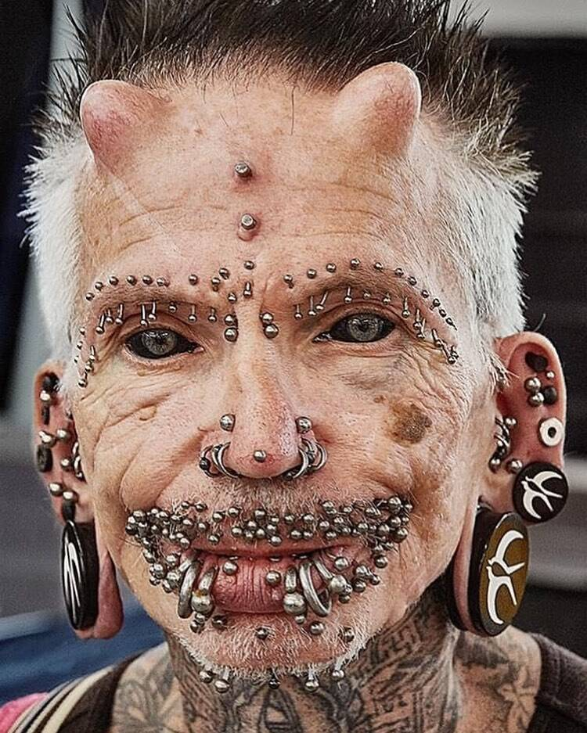

Figure 5: Dennis Avner, Catman (Becoming Something Else).
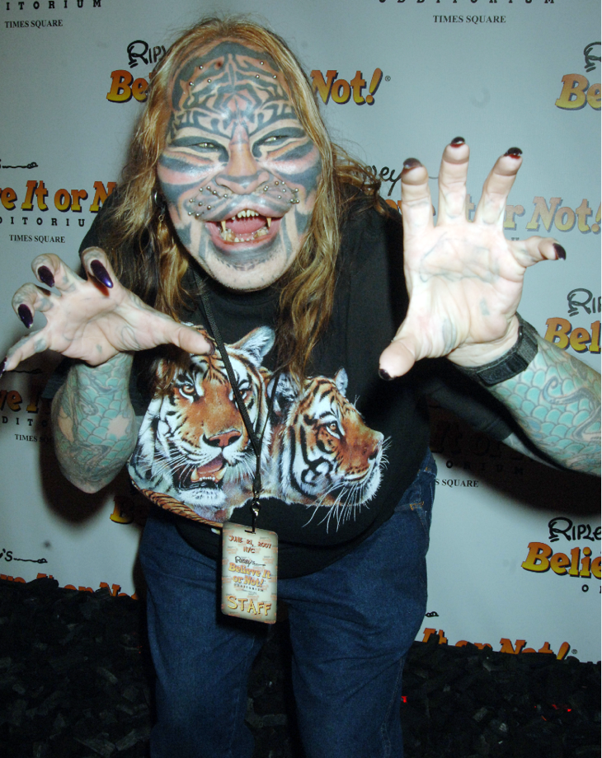

Figure 6: Ötzi the “Ice Man” Tattoos (Samadelli, Marc
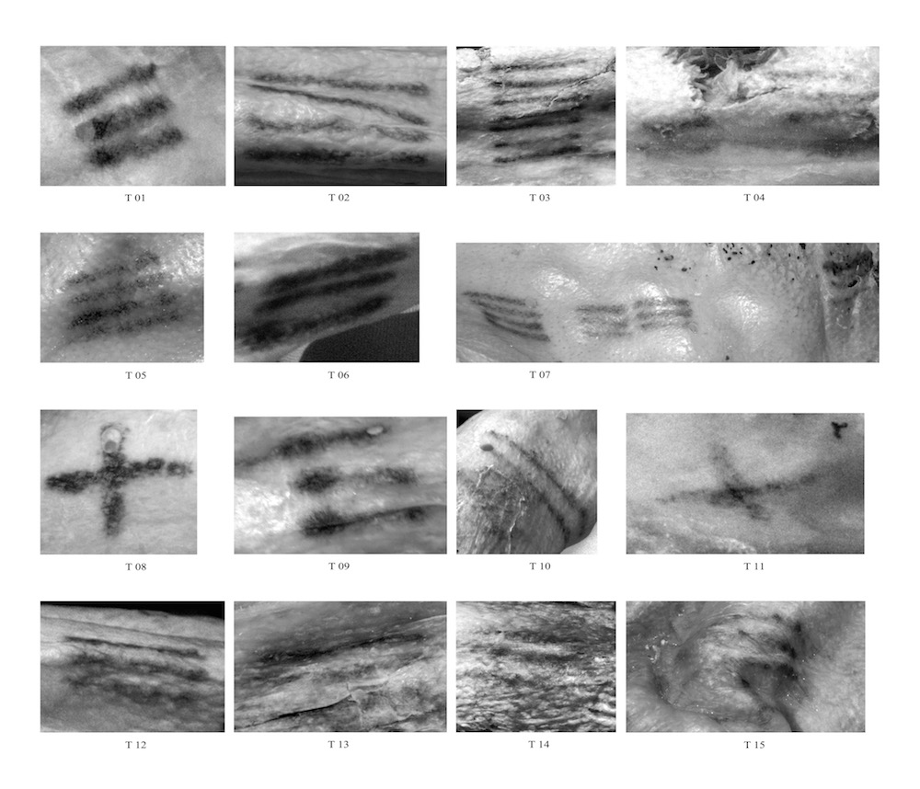

Figure 7: The “American Prince” (Koslofsky, Craig).
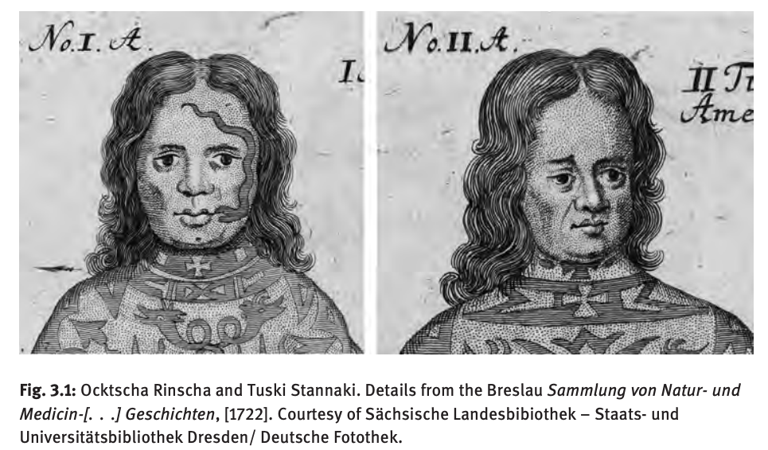

Figure 8: Indian Woman with Nose Ring (Woman Wearing Court Dress and Indian Jewelry)
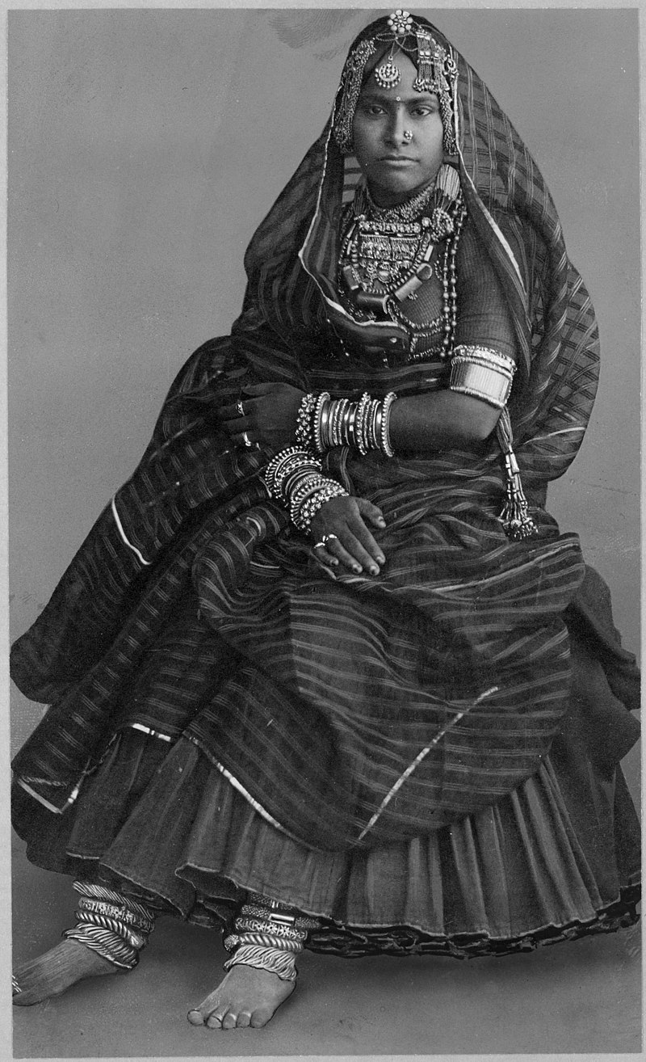

Figure 9: Kayan Woman with Neck Rings (Campagnola, Serena)
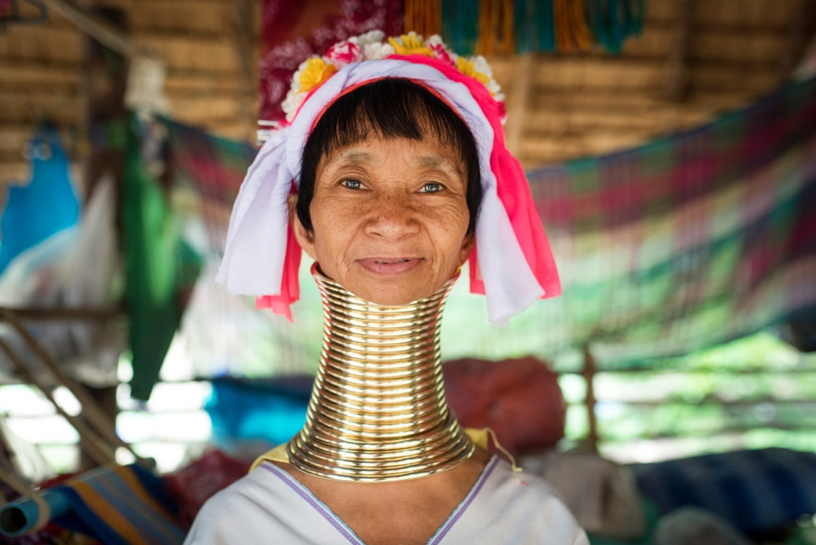

Figure 10: Sean Morgan/ Cryptoon Goonz x Urban Outfitters (Urban Outfitters).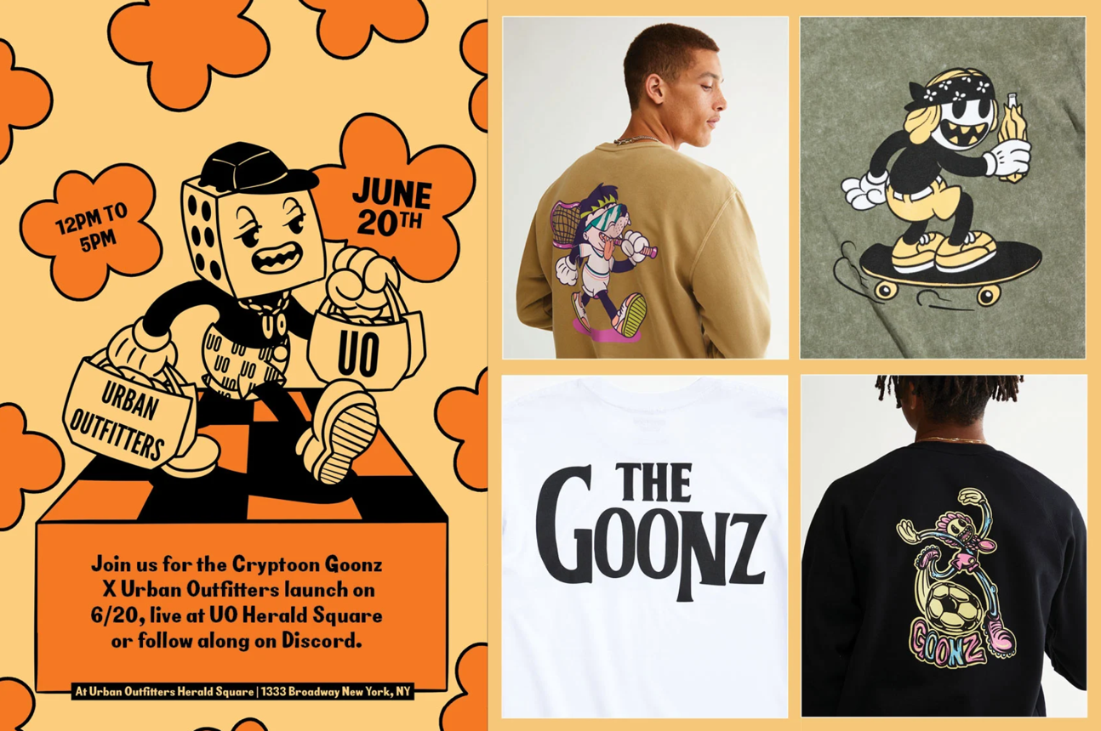

Survey:
The survey that I conducted was inspired by the ‘Need for Uniqueness’ survey conducted by Selina M. Weiler et al. The survey was posted on all of my personal social media accounts such as Tik Tok, Facebook, Instagram, Snapchat, and LinkedIn, and was sent out to the students, staff, and faculty of Cazenovia College. The survey was made public so that others could share it and I could acquire the largest possible sample size with the most diverse group possible. The entire survey was anonymous as well to help reduce bias. I started with the basic demographic-based questions to better understand my audience. Questions based directly around body modifications were then asked. The purpose of this survey was to gain a more personal first-hand account surrounding body modifications by both modified and non-modified individuals.
The questions and answers of the survey are as follows:
